Assignment 6: Automated Web Deployment using Jenkins, Git, and Apache (httpd) on AWS EC2

Github1-Job - Git Configuration & Successful Build

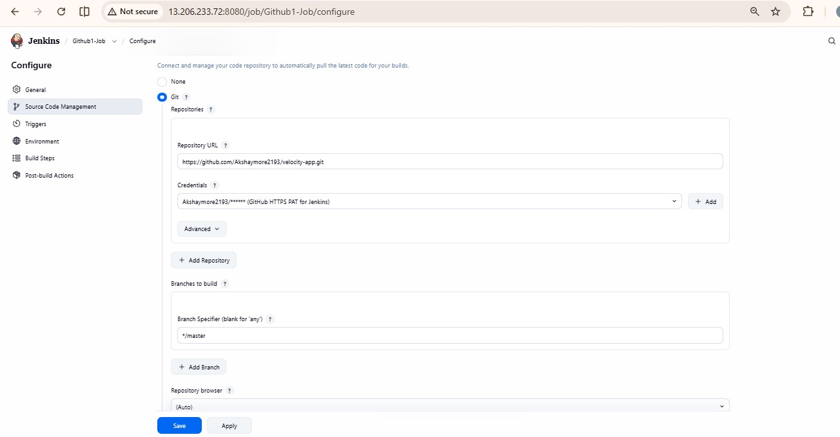

Github2-Job - Branch Configuration & Console Output

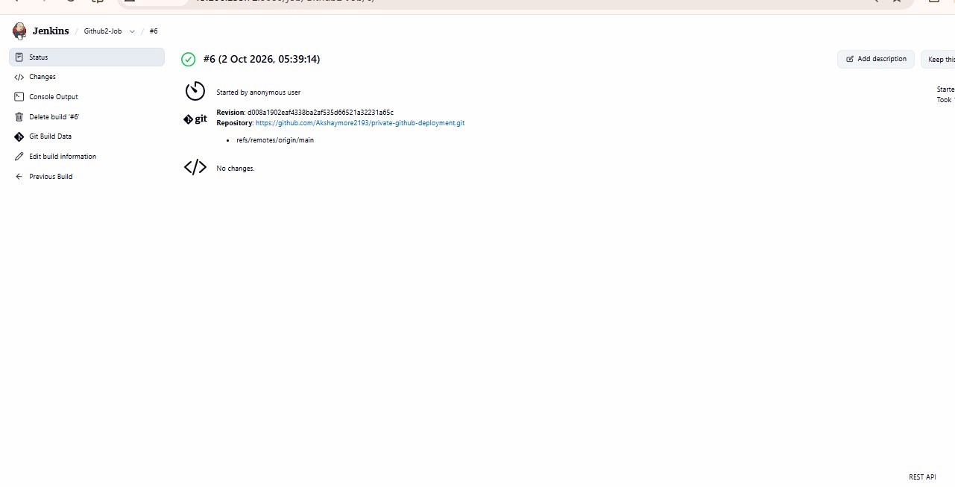
Github3-Job - Execute Shell Script & Build Status
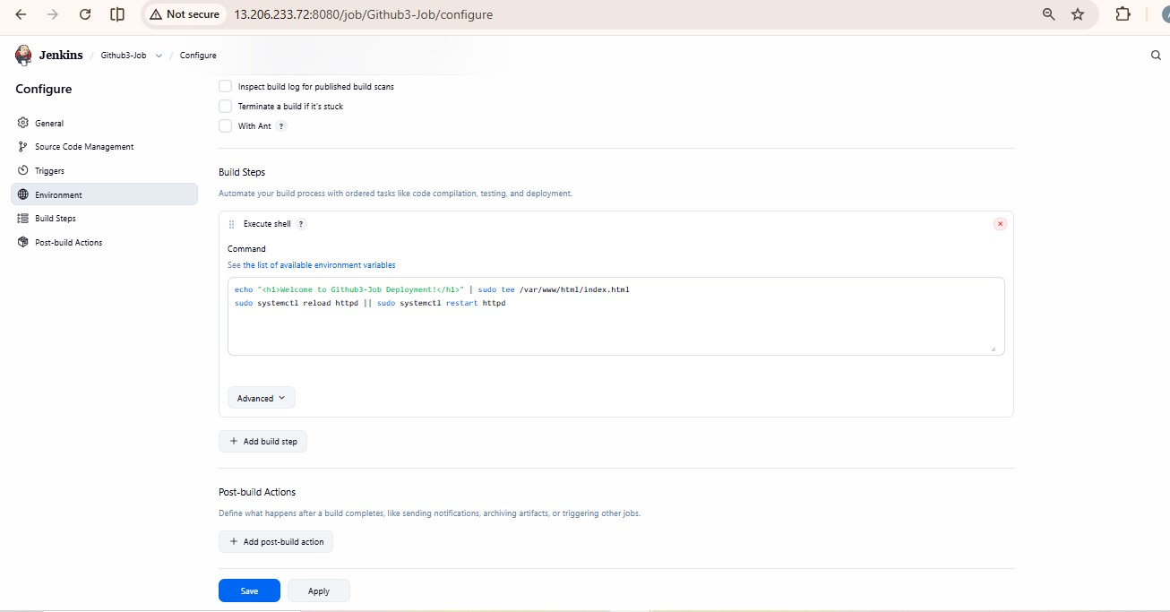

Final Output - Live Webpage on Public IP
